Docker Assignment - Advanced

  - Commands Used:

- Dockerfile Optimization for Build Speed and Image Size:
  - Backend Optimized Dockerfile
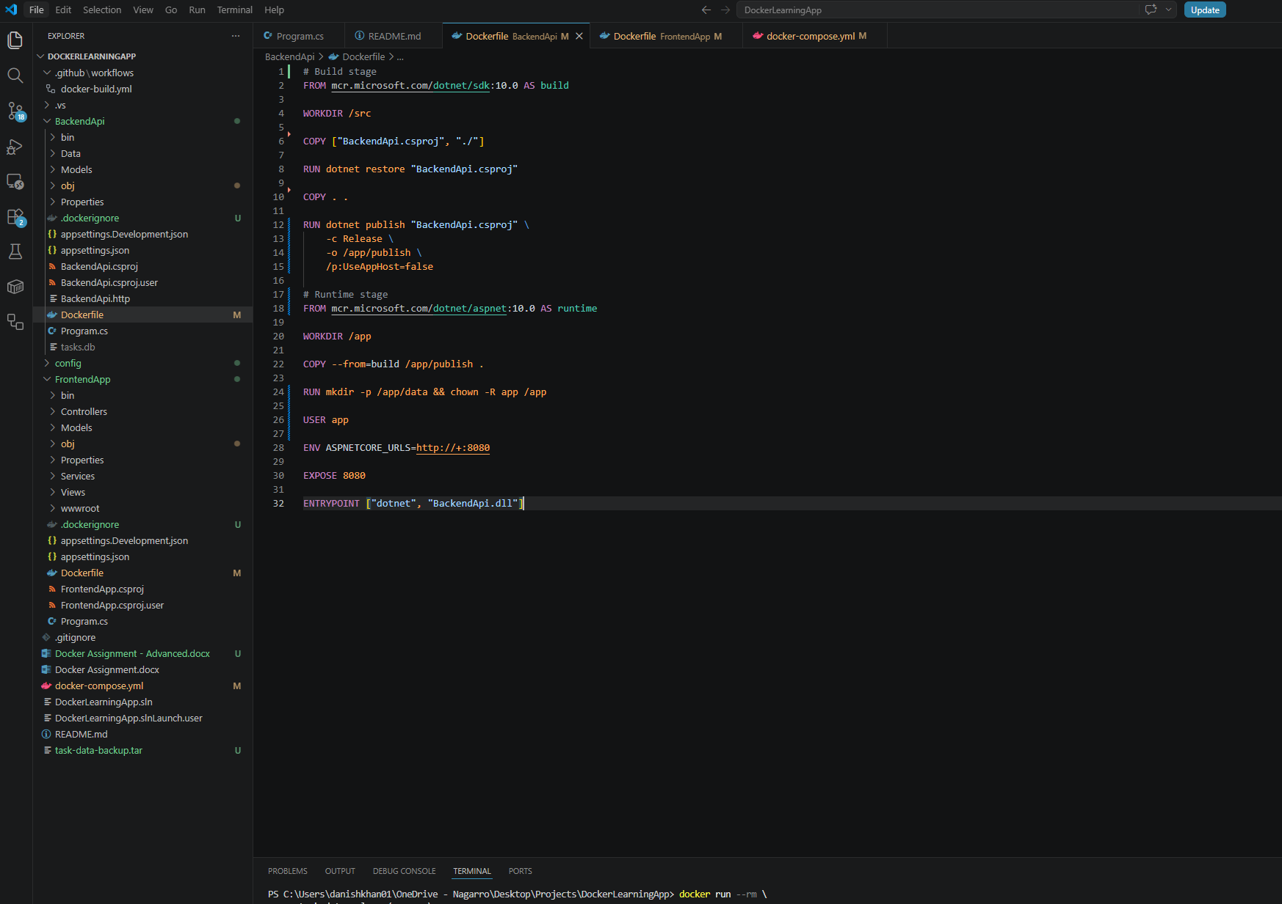
  - Frontend Optimized Dockerfile :
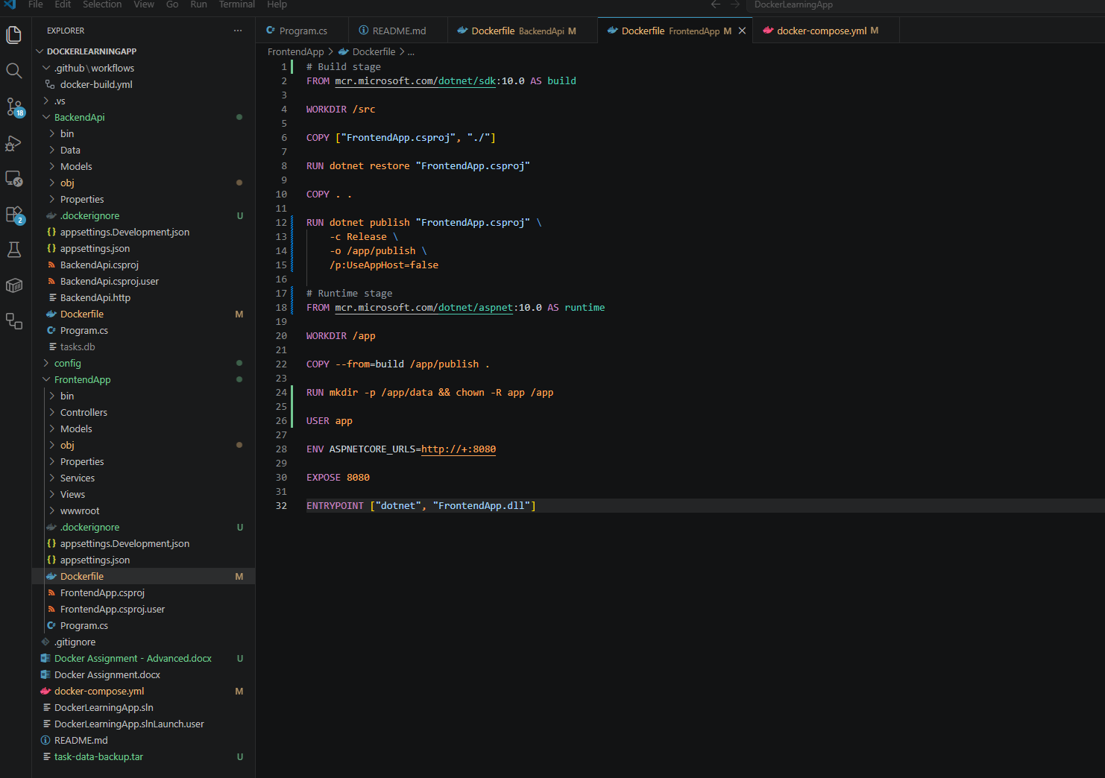
- Build Optimized Images - docker compose up -d –build :
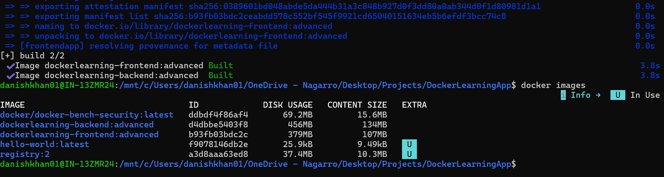
GitHub Repository Link:
https://github.com/DanishKhan-Nagarro/DockerLearningApp
- Set Up Custom Docker Network and Connect Containers:
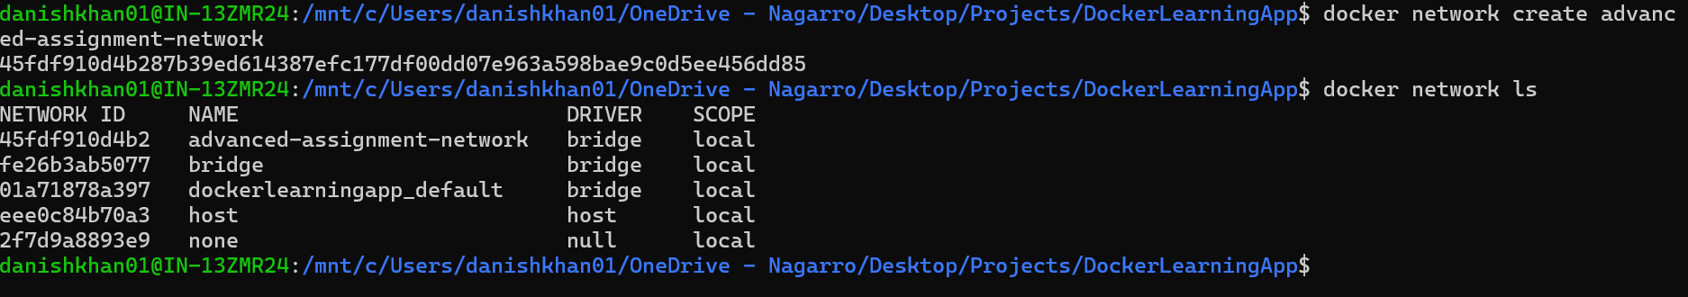
- Use Docker commands to inspect and manage the network:
  - docker network inspect advanced-assignment-network :
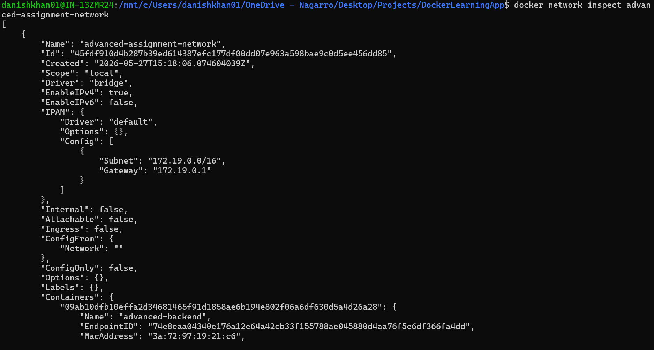

  - Disconnect and Reconnect Frontend Container - docker network disconnect advanced-assignment-network advanced-frontend, docker network connect advanced-assignment-network advanced-frontend:
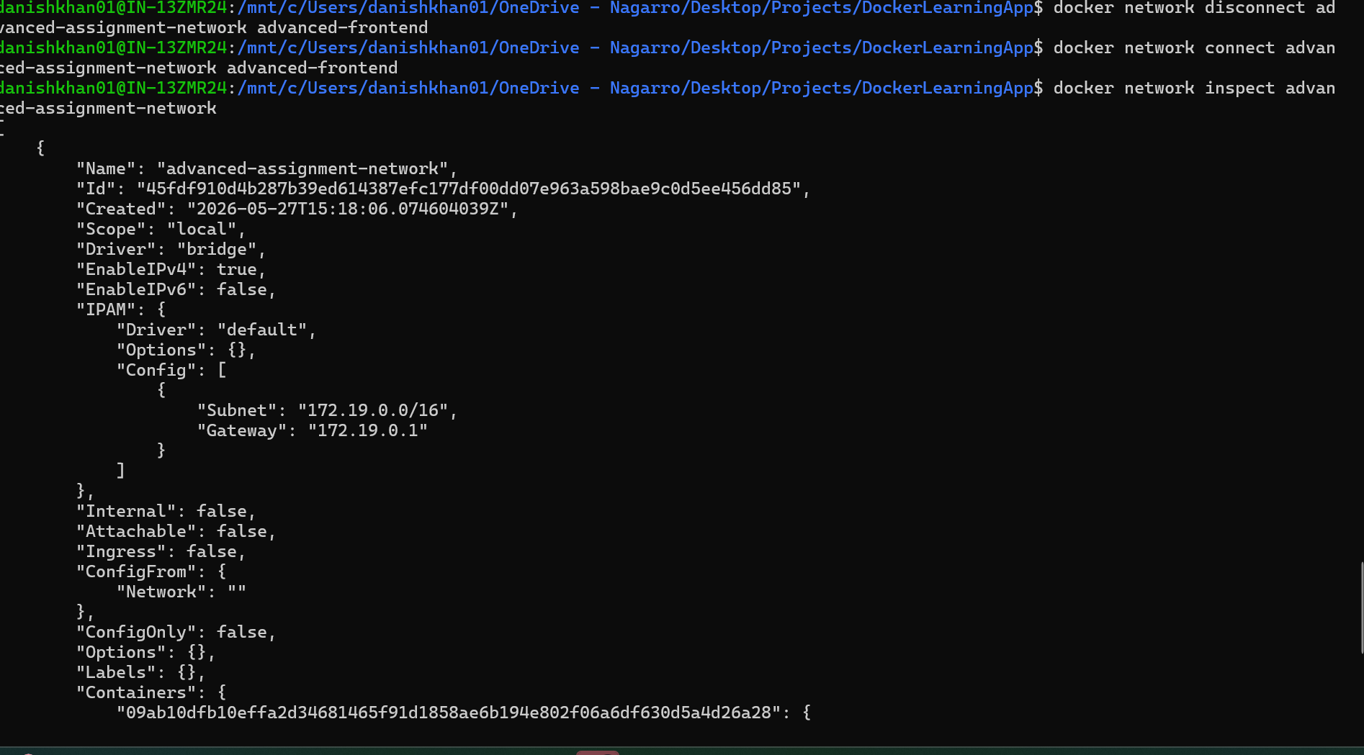

- Create and manage Docker volumes to persist data for your containers –
  - Create Volume - docker volume create task-data-volume, docker volume ls :
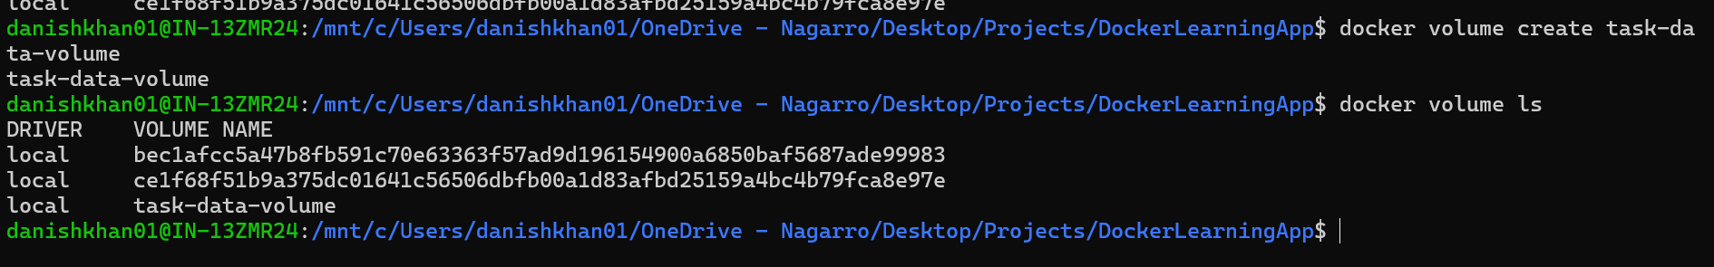
  - Inspect Volume - docker volume inspect task-data-volume :
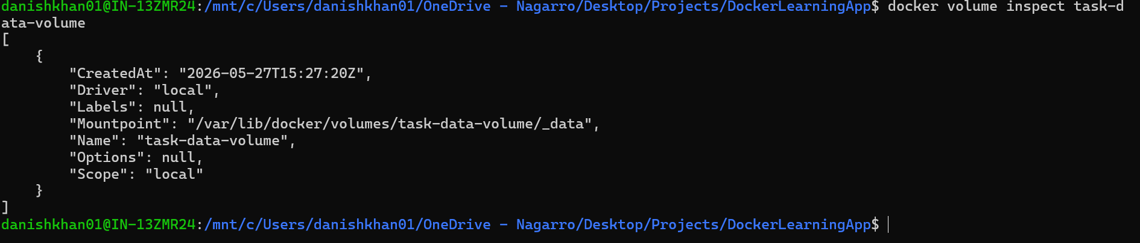

- Use named volumes and bind mounts and demonstrate how they can be used in a multi-container setup - cat config/api_secret.txt :
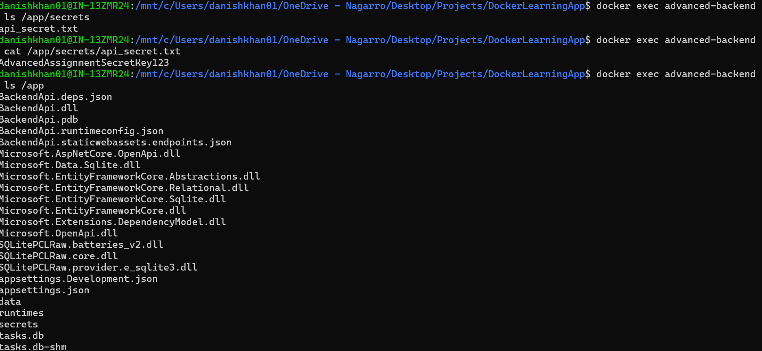

- Backup and restore data from Docker volumes :

  - Create Backup Archive - docker run --rm --entrypoint tar -v task-data-volume:/source -v "/mnt/c/Users/danishkhan01/OneDrive - Nagarro/Desktop/Projects/DockerLearningApp:/backup" dockerlearning-backend:advanced cvf /backup/task-data-backup.tar /source : 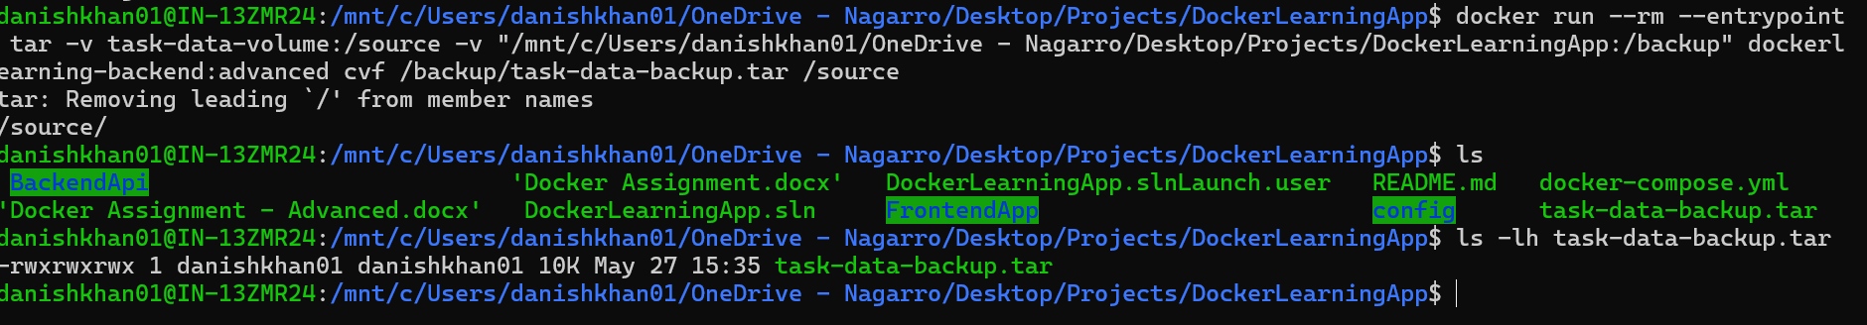
  - Restore Docker Volume - docker run --rm --entrypoint sh -v task-data-volume:/source -v "/mnt/c/Users/danishkhan01/OneDrive - Nagarro/Desktop/Projects/DockerLearningApp:/backup" dockerlearning-backend:advanced -c "cd / && tar xvf /backup/task-data-backup.tar":
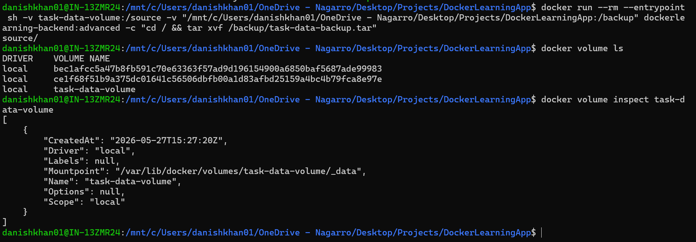

- Implement security best practices in your Docker setup, including user permissions, image vulnerability scanning, and secret management :
  - Verify Backend Container Runs As Non-Root User : 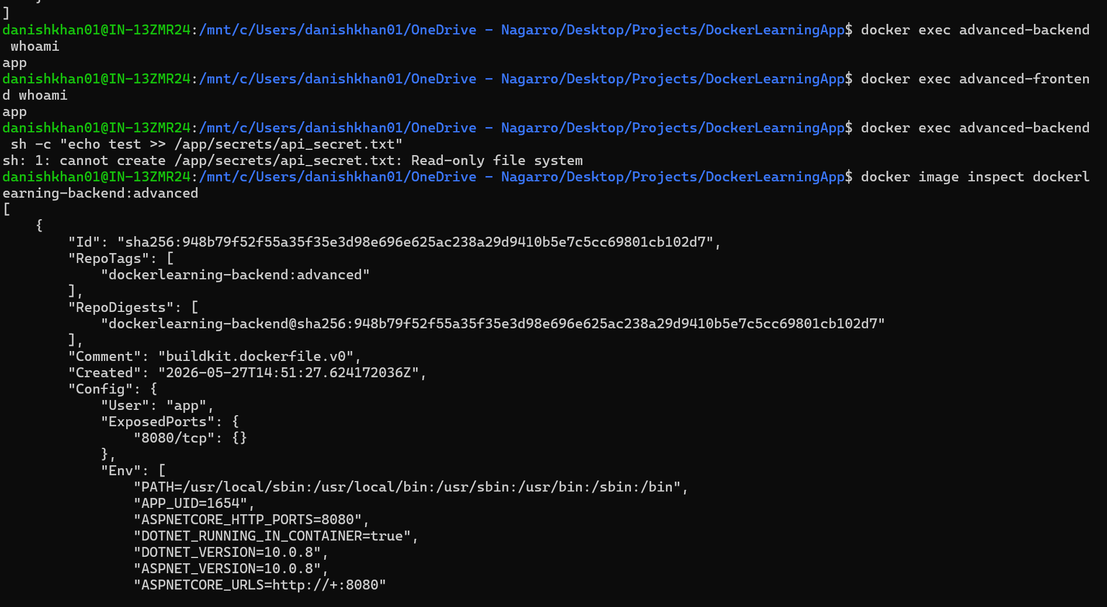
  - docker history dockerlearning-backend:advanced :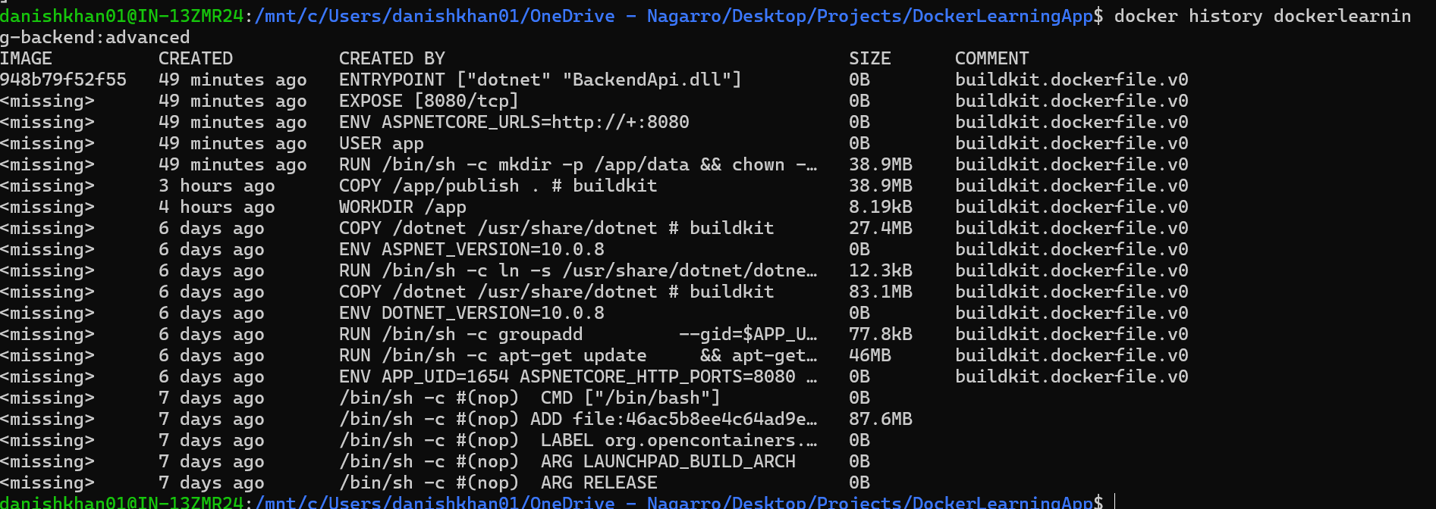
- Configure Docker to run containers with the least privilege. – USER app:
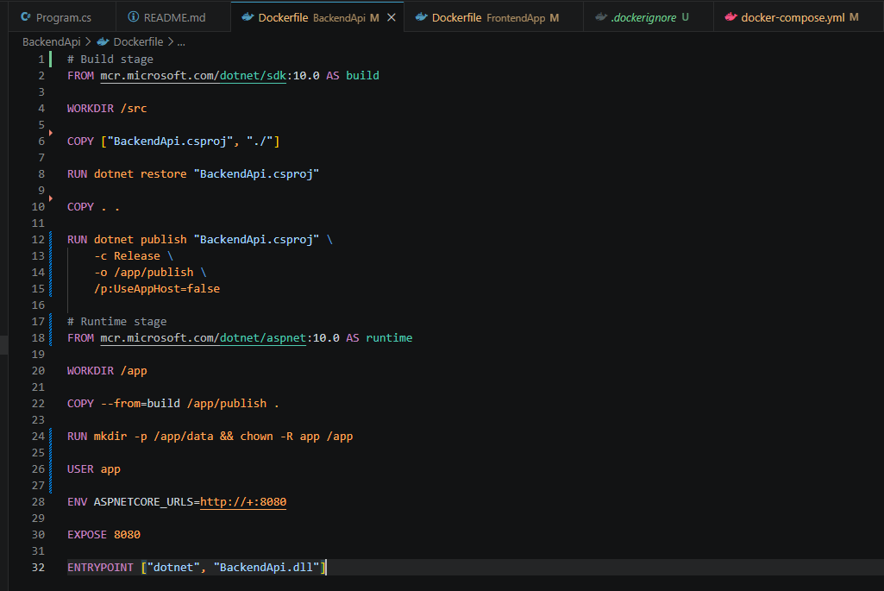

- Use tools like Docker Bench for Security to audit your Docker environment. :
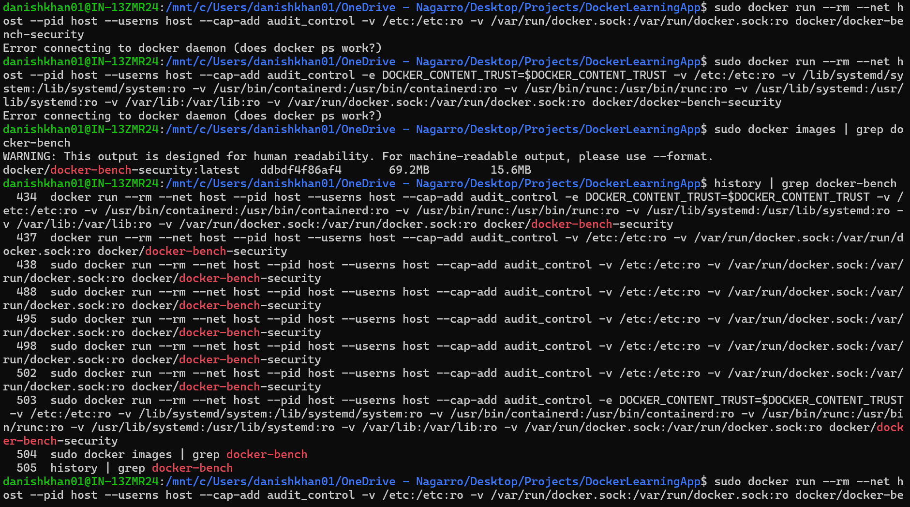
- Final Application URLs:

Frontend Application (Docker): http://localhost:8081
Backend API (Docker): http://localhost:8082/weatherforecast
Tasks (Docker): http://localhost:8081/Tasks
Private Docker Registry (Docker): http://localhost:5001/v2/_catalog

